**Take end devices and a smart phone, and a home gateway:**

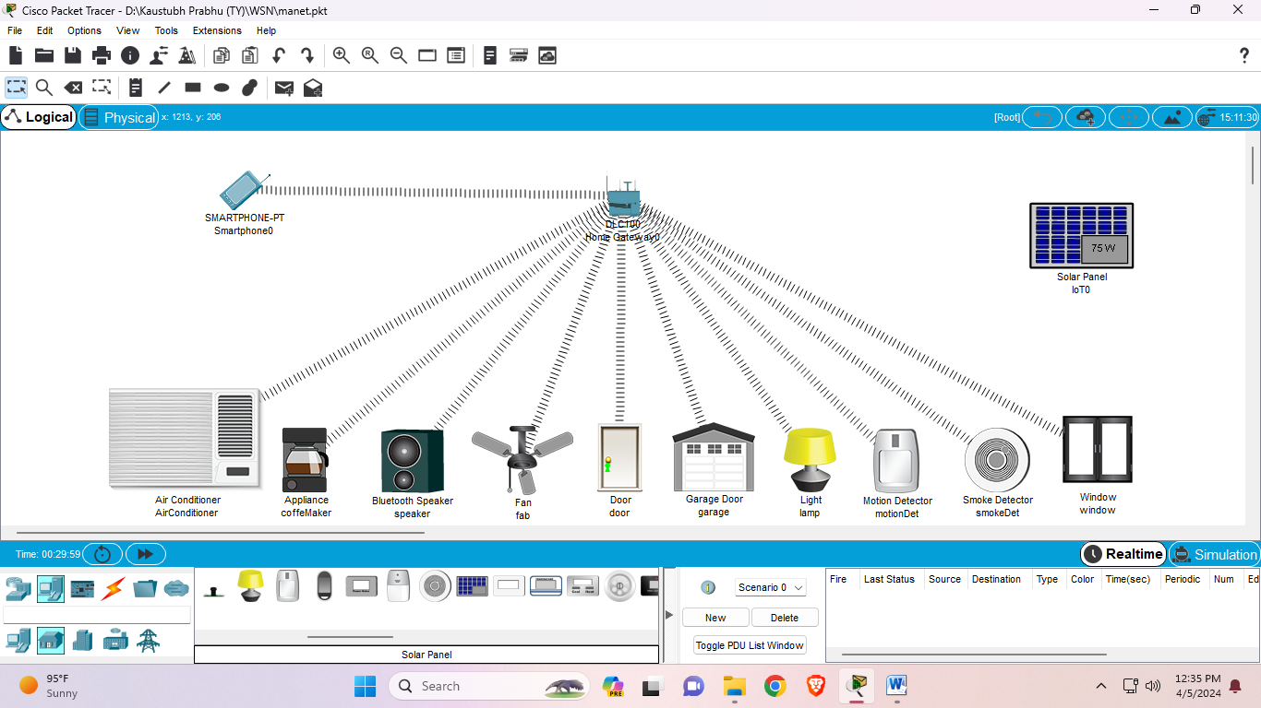

**In solar panel config change the gatewayDns ipv4 to dhcp and GatewyDns IPv4 to Automatic and Iot server to home gateway and In the advanced I/O config, change network adapter to PT-IOT-NM-1W:**

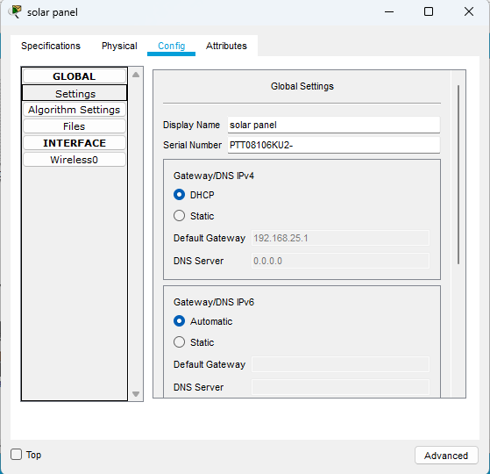

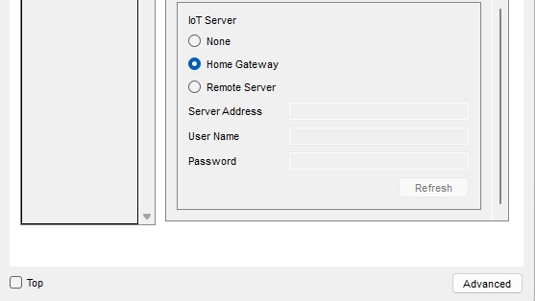

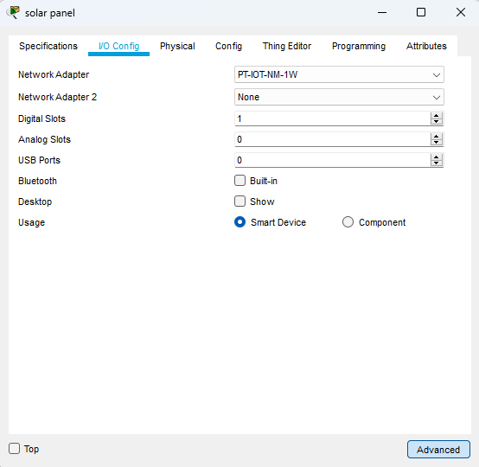

**In the HomeGateway config wireless tab, set SSID and disable authentication:**

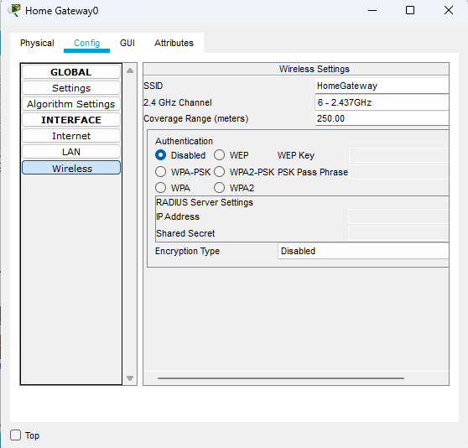

**In smartphone config wireless tab, set SSID same as HomeGateway:**

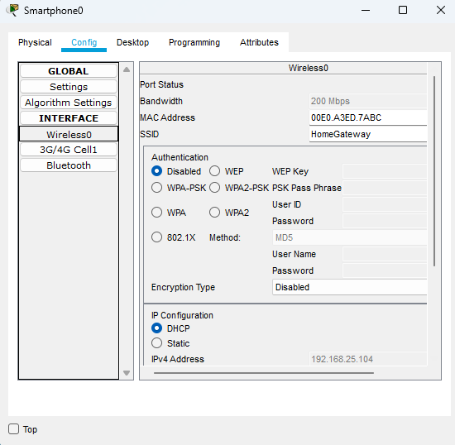

**In smatphone desktop:**

